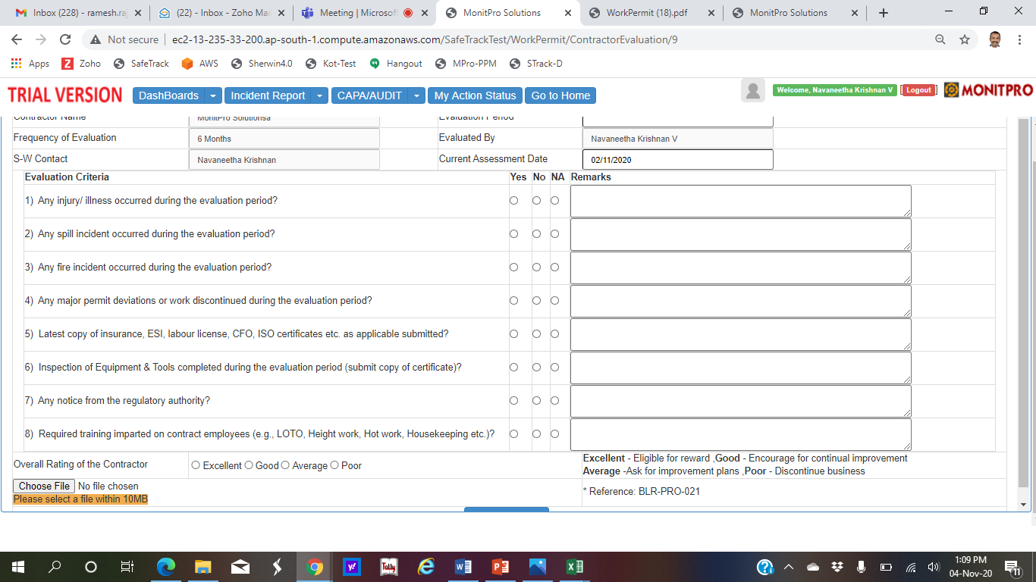

Remove: Refernce: blr….etc

Rename: Contract Approver ?